Given a 2D integer array matrix, return *the* ***transpose*** *of* matrix.

The **transpose** of a matrix is the matrix flipped over its main diagonal, switching the matrix's row and column indices.

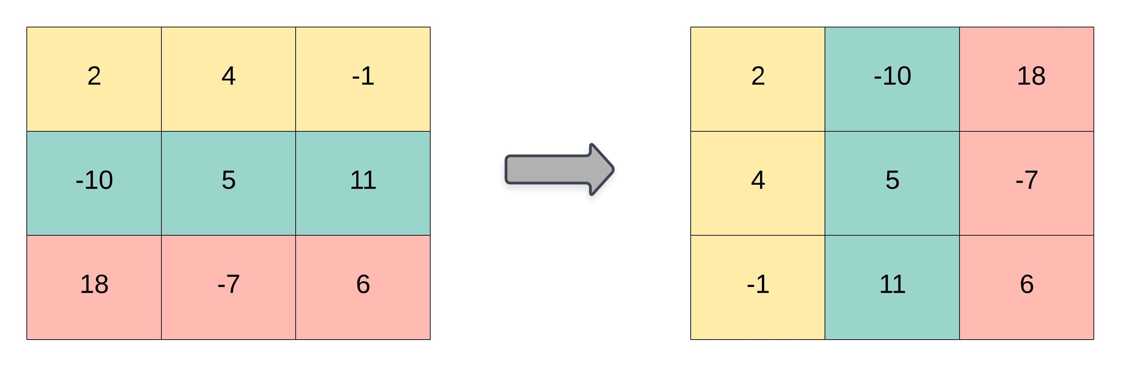

**Example 1:**

Input: matrix = [[1,2,3],[4,5,6],[7,8,9]]  
Output: [[1,4,7],[2,5,8],[3,6,9]]

**Example 2:**

Input: matrix = [[1,2,3],[4,5,6]]  
Output: [[1,4],[2,5],[3,6]]

**Constraints:**

* m == matrix.length
* n == matrix[i].length
* 1 <= m, n <= 1000
* 1 <= m * n <= 105
* -109 <= matrix[i][j] <= 109